

Light system 2D documentation

An open source light system made by oscar7070 for unity LWRP

* How to use?

1. First add the Light2DCameraRenderer component to your camera.



2. Add the Light2DSceneData from menu item LightSystem2D you can’t add more than one Light2DSceneData this object used to get objects info fast.

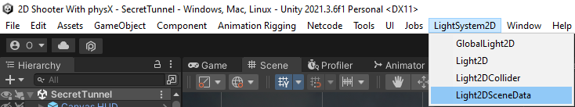

3. Add a game object with a GlobalLight2D component to set the global light is you need.

4. Add a game object with a Light2D component to add the light.

5. Add a game object with a Light2DCollider if you want to cast shadows from objects with Light2D component.

6. If you want to change the settings go to the“Light2DSettings“ file in the Light system 2d folder.

* How to resolve problems?

1. If the light added by you are not see it try to turn on **post processing** in the scene view or check if the Light2DCameraRenderer component is on your camera or check if Light2DSceneData was created.

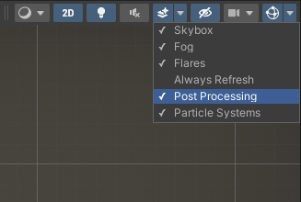

C:\Users\Oscar\AppData\Local\Microsoft\Windows\INetCache\Content.Word\Screenshot_49.png

* If you want to support this project?

If you want to support me you can write about that you use my light system or use the LightSystemLogo image from the LightSystem folder in your game like on game start.

* If I found a issue?

If you found a issue please write to me and I will try to fix it.

That’s was all

Sorry about this small documentation this is just my first serious project (: